The Attica Riverside Cemetery Fund

Charles Rozell established this fund in his will in 1999. Rozell graduated from Attica High School in 1936. He then attended Butler University graduating with a Pharmacy degree in 1942. After serving in the Navy in WWII, he returned to Attica where he owned and operated a pharmacy for many years.
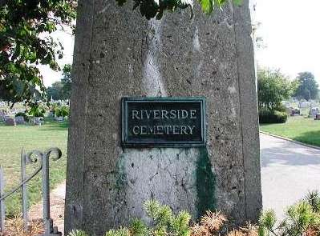
The purpose of the fund is to provide assistance in operating costs and maintenance of the Attica Riverside Cemetery. This is one of four funds established by Charles Rozell, and a tribute to his continuing philanthropic legacy.

