Delmar and Virginia Martin Award Fund
The Delmar and Virginia Martin Fund was established in 2007 in loving memory of the couple, who spent countless hours volunteering in the community. This endowed fund is used for various charitable purposes in the area, including buying children’s books for the Williamsport-Washington Township Library, and helping the Attica High School marching band purchase new shirts for their uniforms. The wider variety of purposes for the fund helps keep alive the memory of the many community contributions made by Delmar and Virginia.

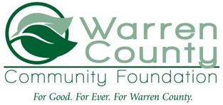
Virginia and Delmar Martin

