NICHES Land Trust Fund
NICHES Land Trust is an organization based in North Central Indiana that focuses on preserving the natural beauty and wildlife of Indiana. NICHES protects seven properties in Warren County totaling 833 acres, with parking and trails at three of those properties. Through the Community Foundation, NICHES Land Trust is able to help preserve the beauty of Warren County, as well as keep our county environmentally sound. Visit nicheslandtrust.org to learn more about the properties and preservation efforts.
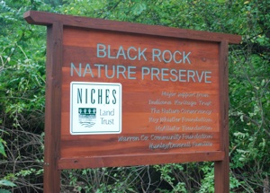
NICHES protects the following Warren County properties: Black Rock, Black Rock Barrens: Heischman-McAdams Reserve, Cranberry Marsh Wildlife Area, Glady’s and Al Wright Rock Creek Nature Reserve, Kohnkes’ Little Pine Village, Hewitt Estate, and Weiler-Leopold Nature Reserve.

