Habitat for Humanity of Benton, Fountain, and Warren Counties
In 2009, the fund for Habitat for Humanity Fund was established by an anonymous donor. This permanent endowment provides funding for the Habitat for Humanity of Benton, Fountain, and Warren Counties each year in order to have funds for the organization when needed. Habitat for Humanity gives a crucial service to the local area by providing affordable housing and helping to eliminate poverty. The local branch of Habitat for Humanity has built approximately a dozen houses since beginning in 1999, and plans to build at least two houses per year. The Foundation is pleased to support this great organization through a permanent endowment that will touch the lives of many families working for a better future.
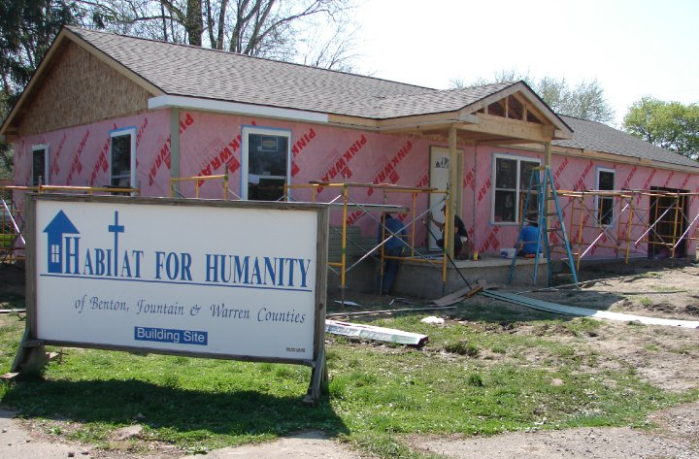
Habitat build site in Fowler.

