Women’s Legacy Builders
The Women’s Legacy Builders, a giving circle within the Warren County Community Foundation, was organized in 2004 to promote philanthropy and build an endowment that would strengthen Warren County. Members of the group are dedicated women who want to enrich county programs through their annual support of membership. Because of the commitment from this special group of Warren County women, non-profits are invited to apply for a Legacy Grant each spring. This group also brings together women to share their lives and improve the lives of others in the community. The annual Legacy Builders event features speakers on women’s issues and interests to inspire women to leave a lasting legacy in Warren County. The event is always filled with friends, good, and fellowship.
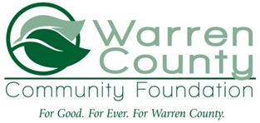
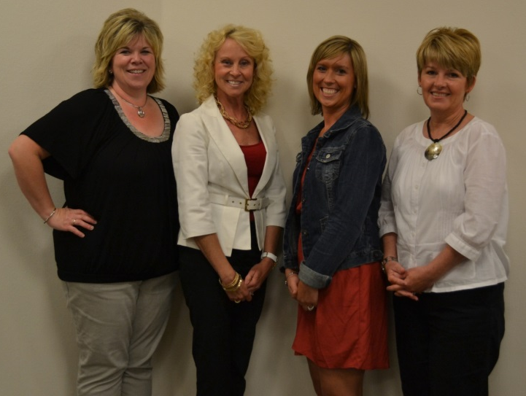
Women’s Legacy Builders Steering Committee

