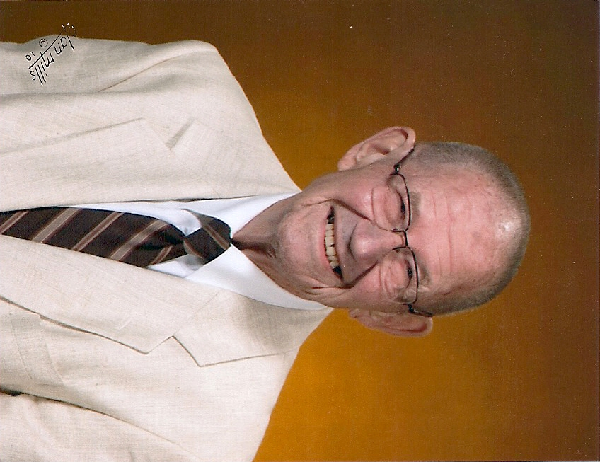
The Charlie Coffman Memorial Fund

Charlie served in the Army in the Glider Infantry in France during World War II. He was wounded in France and was awarded the Purple Heart. He was a member of the Pine Village Christian church where he served as an elder for over 40 years and was the pianist and organist for nearly 55 years. He taught the Veterans' Agriculture class at Attica High School for 2 1/2 years, taught Vocational Agriculture and Science at Pine Village High School for 23 years and served as Supervising Principal for 2/12 years. He taught at MSD of Warren County for 13 years as a Vocational Agriculture Teacher and Cooperative Education Coordinator. This fund provides support to students who have lived in Warren County a minimum of 12 months and who have, or anticipate graduating from Seeger High School. Students must have a minimum GPA of 2.5, be accepted to pursue a course of study at an accredited vocational or technical school, college or university. Priority will be given to students demonstrating a need for tuition assistance.

