WCCF Board Alumni Fund
The WCCF Board Alumni Fund was formed in 2011 to help former members of the Warren County Community Foundation Board maintain an involvement in the Foundation. The group meets once a year to catch up on the progress of the Foundation and to give a grant to a community organization or fund within the Foundation. Each member present is eligible to be drawn from a hat to choose the organization of that year’s grant.
The members also eat pie at the meeting, as suggested by the group’s description. However, PIE stands for Promote, Inform, and Engage, which are the goals of the group. Members of the PIE group wish to continue helping the Foundation grow and stay involved even after they have retired from the board.
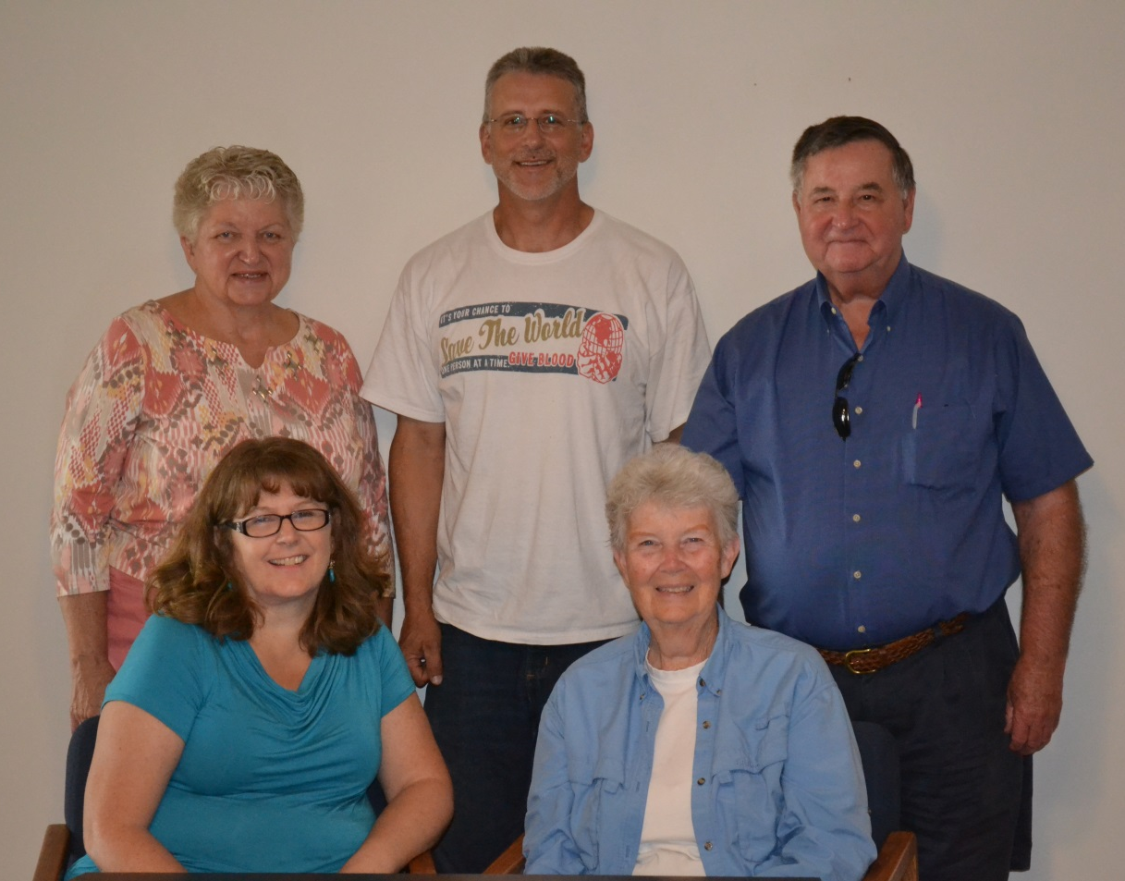
The Alumni PIE group

