Warren County Nursing Home Care Givers Education
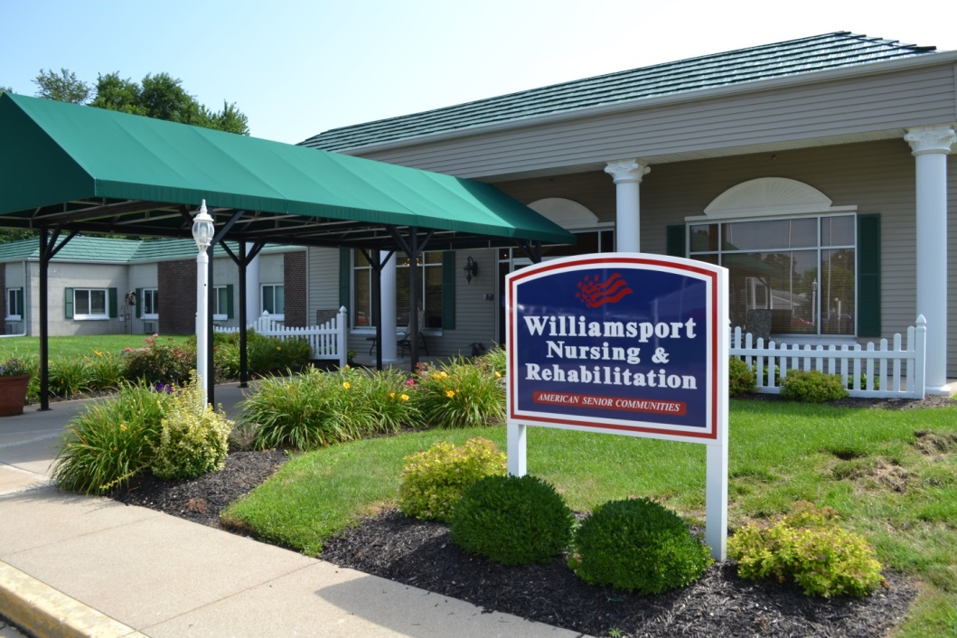
In 2003, Dixie Slauter realized the need for more nursing home care givers in Warren County. She greatly appreciated the care her mother received while staying at a nursing home, but knew that the staff was struggling to keep up with demand and needed more help. Dixie established a fund with the Community Foundation to help give educational opportunities to Warren County residents who wish to become Certified Nursing Assistants and Qualified Medication Assistants. Grants will also be available for seminars and other training opportunities when other sources of funding are not available.

